CJFAS Article

Network-scale thermal and habitat heterogeneity structures a diverse Chinook salmon spawning portfolio

Russell F. Thurow^{1†*} (ORCID iD: 0000-0002-1362-8599)
Bryan M. Maitland^{2†} (ORCID iD: 0000-0002-4491-5064)
Morgan M. Sparks² (ORCID iD: 0000-0003-0787-2218)
Daniel J. Isaak² (ORCID iD: 0000-0003-2963-1546)
John M. Buffington² (ORCID iD: 0000-0002-2513-5863)

¹US Forest Service, Rocky Mountain Research Station (Emeritus), Salmon, ID, USA 83467
²US Forest Service- Rocky Mountain Research Station, Boise, Idaho, USA 83702.
† Dual first authors
*Corresponding author (e-mail: russ.thurow@usda.gov)
Abstract
Pacific salmon exhibit diverse life histories and local adaptation shaped by spatiotemporal variation in biotic and abiotic conditions. This biocomplexity buffers populations against environmental variability and reduces risks of demographic failure. One key aspect of biocomplexity is spawning phenology—the timing associated with gonadal maturation and egg deposition. Previous studies of salmonid spawning phenology have often been constrained to a small number of sample sites, which limits our understanding of the importance of spatial diversity in promoting biocomplexity and resilience. To this end, we analyzed 3,016 wild Chinook salmon (Oncorhynchus tshawytscha) redds georeferenced from 2002-2005 across diverse habitats in a wilderness river network and evaluated how stream- and reach-scale thermal conditions influenced spawn timing. Linear mixed-effects models with stream-reach random intercepts and slopes explained most of the variation in observed salmon spawning dates (marginal R² = 0.599; conditional R² = 0.990). Predicted mean spawn timing across the network averaged 29 August, with a range of 18 days from 20 August to 7 September. Spawn timing occurred earlier in sites with cooler antecedent 90-day mean water temperature but plateaued at the warmest sites in downstream areas. Stream and year effects were also significant, with spawning occurring progressively later across years from 27 August in 2002 to 2 September in 2005, broadly consistent with warmer antecedent temperatures in later years. Importantly, reach-specific random slopes revealed heterogeneity in thermal sensitivity, suggesting that unmeasured local hydrologic and geomorphic processes mediate phenological responses to temperature. Together, these results demonstrate that fine-scale habitat and thermal heterogeneity, expressed throughout a river network, structures phenological diversity in this interior Chinook salmon population. Notably, we documented the persistence of diverse spawn timing and sensitivity within this salmon population, despite low contemporary abundances and “Threatened” status under the U.S. Endangered Species Act. Conserving diversity in spawn timing across heterogeneous habitats may be critical for maintaining the adaptive capacity of Chinook salmon to dynamic environments.

Keywords
Spawn timing, portfolio effect, biocomplexity, life history diversity, phenotypic plasticity, habitat heterogeneity, resilience
Introduction
Pacific Salmon populations exhibit extraordinary life history diversity, shaped by complex and heterogeneous environments across their range (Brannon et al. 2004). The enormous diversity of salmon life history traits (Waples et al. 2004) evolved in response to spatiotemporal variation in both biotic and abiotic conditions (Stearns 1976; Montgomery 2000) and acts to reduce risks of demographic failure by buffering populations against environmental change and exploitation (Hilborn et al. 2003, Greene et al. 2009; Schindler et al. 2010; Beamish 2016). Chinook salmon (Oncorhynchus tshawytscha) display an especially diverse demographic portfolio characterized by a broad array of phenotypes, including variation in age and timing of seaward migration, duration of freshwater and marine residence, ocean distribution, age and season of spawning migration, and timing of spawning (Healey 1991).
Among these traits, spawning phenology has important ecological and evolutionary consequences. The timing of adult migrations and subsequent spawning play important roles in shaping reproductive isolation among temporally segregated groups and contributes to fine-scale local adaptation (Quinn et al. 2001; Manhard et al. 2017). While migration and run timing (entry into freshwater) are often used to define subspecific groupings (e.g., spring, summer, or fall-runs; Brannon et al. 2004; Waples et al. 2004), spawn timing (the date adults deposit fertilized eggs) expresses important salmon phenotypic variation. Spawn timing often varies significantly among local populations in response to both genetic components (Ricker 1972; Quinn et al. 2002; Beulke et al. 2023) and local habitat conditions (Kaylor et al. 2022; Jacobs et al. 2023). Within habitats, temperature strongly influences salmonid spawn timing (Henderson 1963; Morrison and Smith 1986; Beechie et al. 2008) because embryonic development rates are mechanistically driven by thermal conditions (Beacham and Murray 1990) and salmon spawn at times that ultimately synchronize fry emergence with conditions optimizing offspring growth and survival (Quinn 2018; though see Sparks et al. 2019). As a result, many studies have linked thermal regimes to observed variation in spawn timing (Sheridan 1962; Burger et al. 1985; Heggberget 1988; Lisi et al. 2013). Because thermal regimes vary predictably across stream networks with topography, catchment area, and local hydrogeology, spatially diverse river systems are expected to support corresponding diversity in spawn timing — a phenological portfolio structured by the network's thermal landscape. Characterizing this portfolio requires pairing spatially explicit thermal data with reach-scale observations across a range of environments, an approach that has only recently become tractable with the development of high-resolution stream temperature models. However, most previous work has been conducted within laboratory settings or at relatively small field scales, and studies characterizing phenological portfolios across broader areas with diverse thermal conditions remain lacking.
Recent development of accurate, high-resolution stream network temperature models creates new opportunities for studying salmonid spawning phenology at network scales. These models provide interpolated predictions at 1–3 km spatial resolution across entire river networks (McNyset et al. 2015; Isaak et al. 2017), enabling reach-scale thermal conditions to be linked directly to biological observations across diverse environments. To facilitate phenological applications, models with hourly or daily temperature predictions allow intra-annual biological variation to be cross-referenced with intra-annual thermal variation (Jackson et al. 2018; Siegel et al. 2023). However, temperature models reflect conditions at the reach scale and do not capture microhabitat-level thermal heterogeneity within spawning sites (Fullerton et al. 2018; O’Sullivan et al. 2019), which may contribute to residual variation in spawn timing beyond what thermal models alone can explain. Consequently, the relationship between fine-scale thermal heterogeneity and spawn timing is poorly understood (Deacy et al. 2019).
Understanding the broader patterns and causes of phenological spawning diversity is of critical importance to the resilience and recovery of Pacific salmon (Taylor 1991; Waples et al. 2004). Characterizing variation in natural processes within stream networks and understanding how spatial and temporal variability in physical processes interact with Pacific salmon provide critical information for establishing recovery targets (Bisson et al. 2009) and evaluating population persistence under changing environmental conditions (Craig et al. 2017, Isaak et al. 2018). Here, we pair modeled daily stream temperature scenarios with a unique spawning phenology dataset from a central Idaho wilderness river network to examine how thermal regimes influence wild Chinook salmon spawn timing across a wide range of climatic conditions and physical environments. Our objectives were to: 1) describe stream reach-scale physical attributes and Chinook salmon spawning phenology from 2002 to 2005, 2) summarize variation in spawn timing across four years in eight streams, and 3) fit a series of linear mixed-effects models to identify associations between thermal conditions and spawn timing. Our goal is explicitly descriptive: to characterize the structure and environmental determinants of spawn timing variation within the network at fine spatial resolution, rather than to develop a transferable predictive framework. The reach-level detail afforded by our approach provides a foundation for future comparative work across broader geographic scales.

Methods
Study Area
We did this study in the Middle Fork Salmon River (Middle Fork), which drains ~7,330 km² of central Idaho and lies predominantly within the Frank Church River of No Return Wilderness (Figure 1). One of eight original National Wild and Scenic Rivers designated in 1968 (NWSRS 2016), it flows 171 km from its headwaters before joining the Salmon River near Salmon, Idaho (USFS 1998; Thurow et al. 2020). Approximately 1,100 km of Middle Fork mainstem and tributary habitats are accessible to and used by Chinook salmon for spawning and rearing (Buffington et al. 2026). These salmon populations are composed of wild, indigenous fish unaltered by direct hatchery supplementation (Thurow et al. 2020) and the watershed is managed as a designated wild anadromous fish sanctuary (IDFG 2019). Minimal anthropogenic effects and a geographic size that facilitates natural processes (i.e., wildfire, floods, debris flows, and snow avalanches) ensure generation and maintenance of diverse environmental conditions (Thurow 2015). These natural processes function relatively unimpeded by humans because most of the watershed lies within designated Wilderness. As a result, natal salmon habitats remain diverse, high quality, and connected, with non-native fish species relatively uncommon (Thurow 2000; Isaak and Thurow 2006; Thurow 2015). More details regarding the Middle Fork can be found in Minshall et al. (1981); Thurow (2000); Servheen and Huntington (2001); and Thurow et al. (2020).
Adult Chinook salmon migrate from the Pacific Ocean up the Columbia and Snake rivers to spawn in the Middle Fork, typically arriving in early summer and spawning from late July to mid-September. Salmon in this system express a stream-type life history, with most juveniles rearing for one year in freshwater before outmigration (Healey 1991). However, fish exhibit multiple freshwater (age 0-2) and saltwater (1-5) ages, in addition to non-migrating precocial males (Gebhards 1960; James et al. 1998; Copeland and Venditti 2009). Observations suggest that early-arriving adults tend to spawn at higher elevations and later arrivals spawn progressively lower in the basin (Fulton 1968; Gebhards 1959; Parkhurst 1950). Spawning elevations range from 900 m in the lower mainstem Middle Fork to 2,000 m in tributary headwaters.
Despite the Middle Fork’s high quality natal habitat, its Chinook salmon are at high risk of extirpation (NMFS 2017). These fish belong to the Snake River spring/summer Chinook salmon Evolutionarily Significant Unit (ESU), listed as “Threatened” under the Endangered Species Act (ESA; NMFS 1992). Current salmon populations average 1-3% of the abundances that annually returned into the mid-1960s (Thurow et al. 2020). Altered migration corridors are considered a proximate cause of salmon declines in the upper Snake River basin in recent decades (Jacobs et al. 2023). The US National Oceanic and Atmospheric Administration (NOAA 2022) stated that the centerpiece recovery action is restoring more normalized reach-scale hydrology and hydraulics, and thus normalized river conditions and function in the lower Snake River and emphasized the urgency of actions is accentuated by climate change.

Reach selection, Chinook salmon redd counts, and spawn timing
Middle Fork Chinook salmon are some of the most intensively monitored populations in the Columbia River Basin with long-term redd index reach surveys conducted by state, federal, and tribal agencies dating back to the 1950s (Parkhurst 1950; Gebhards 1959; Mallet 1974). For this research, we monitored a subset of these areas intensively from 2002-2005 in eight major spawning tributaries (Figure 1). The areas surveyed encompassed 101.4 stream km and a range of elevations (1,166 – 2,054 m) and reach slopes (~0 – 4.8 %). To support collaboration and improve efficiency, some study reaches overlapped with existing index reaches monitored annually by the Idaho Department of Fish and Game (IDFG), the Nez Perce Tribe, Shoshone Bannock Tribe, or the U.S. Forest Service (see Thurow et al. 2020 for index reach methods and locations). After selecting reaches, surveyors designated and marked subsections where redds would be identified and georeferenced.
Redd surveyors intensively monitored Chinook salmon spawning from the onset of redd construction in late July through the completion of spawning in mid-September. Trained observers walked stream banks within each study reach on 3-5-day intervals, searched for newly constructed redds, and georeferenced these locations with GPS units. To avoid commission errors, surveys began prior to redd construction and during initial surveys, observers recorded all prior year redds or redd-like streambed features that might have been confused with newly constructed redds. Based on our prior observations in the Salmon River basin, female Chinook salmon typically remain on excavated redds for 3-5 days. Consequently, we assumed our 3-5-day survey interval maximized the likelihood of detecting redds soon after their construction.
Based on our survey intervals, we inferred spawn timing from the first date a redd was fully constructed. Redd locations were spatially joined to stream reaches in the NHDPlus dataset (McKay et al. 2019) and assigned a common identifier (COMID). This identifier was used to link each redd with environmental covariates measured in or derived from the corresponding stream reach. The final dataset contained 3,016 georeferenced redds with completion dates and 104 unique stream reach COMIDs across four years within eight spawning tributaries.

Covariates
Stream temperature is the primary abiotic driver of salmonid spawning phenology, as thermal conditions govern the pace of gonadal maturation and the timing of redd construction in ectothermic fishes (Quinn 2018; Lisi et al. 2013). We therefore expected spawn timing to occur earlier at thermally cooler sites. However, this relationship may not be linear across the full thermal gradient. Embryo development rates in salmonids exhibit compensatory responses to temperature — development accelerates disproportionately in cold water — such that the sensitivity of spawn timing to temperature diminishes toward the cold margin of the thermal spectrum (Brannon et al. 2004; Beer and Steel 2018). At the warm margin, energetic and physiological constraints on pre-spawn staging may limit how late spawning can be delayed regardless of further warming (Plumb 2018), producing an asymptotic or plateau response at high temperatures. We therefore anticipated a nonlinear relationship between antecedent stream temperature and spawn timing, with the strongest thermal sensitivity at intermediate temperatures and reduced responsiveness at thermal extremes. We indexed thermal conditions using modeled daily stream temperatures at the COMID level from Siegel et al. (2023), after confirming strong agreement with empirical temperature data measured in Idaho (Figure A1.7).
We summarized temperature variability using 30-, 60-, and 90-day averages prior to, during, and following the inferred spawn date at each redd location. Based on an initial exploratory analysis (Appendix A2), we retained 90-day antecedent temperature (temp_90; hereafter “temperature”) as the sole thermal covariate because shorter antecedent window metrics were highly correlated (r = 0.55–0.95) and more weakly associated with spawn date. Post-spawn and fixed-date summaries were weakly associated with spawn timing and were also excluded from further consideration. Mean 90-day antecedent temperatures in 2002-2005 were 11.2, 11.8, 11.4, and 11.7, respectively.

Data analysis
We used linear mixed-effects models (lme4; Bates et al. 2015) to evaluate the covariates of Chinook salmon spawn timing, using redd completion day-of-year as the response variable. Continuous covariates were rescaled (mean = 0, SD = 1) to aid convergence and model interpretation. All models included a random intercept for COMID to account for repeated measures across stream reaches. Based on residual diagnostics from initial models and biological expectations of nonlinear thermal responses—including a potential plateau at warm temperatures—we evaluated multiple functional forms of the temperature effect using quadratic and natural spline terms. Model selection proceeded in three stages, with full details provided in Appendix A3. First, we fit seven additive models representing all combinations of temperature (quadratic), stream, and year as fixed effects and selected the most parsimonious base model using AIC. Second, we extended the base model with COMID-specific random slopes for temperature to assess whether thermal sensitivity varied across reaches, comparing models fit with restricted maximum likelihood. Third, we evaluated alternative functional forms for the temperature effect — quadratic and natural spline terms with three and four degrees of freedom — to assess whether a more flexible form better captured the nonlinear temperature–spawn timing relationship. The final model was refit with REML for parameter estimation and interpretation. We estimated marginal mean spawn timing at each level of stream and year from the final model using the emmeans package (Lenth 2024), averaging over random effects to provide population-level estimates of fixed effect contrasts. Pairwise differences between streams and years were evaluated using Tukey-adjusted p-values. We assessed model fit and residual diagnostics using marginal and conditional R² (Nakagawa and Schielzeth 2013), RMSE, intraclass correlation coefficients (ICC), and DHARMa simulated residuals (Hartig 2022); full diagnostic output is provided in Appendix A4.

Results
Observed spawn timing
Across all streams and years, Chinook salmon spawning exhibited a broadly unimodal distribution, with most activity concentrated between 20 August and 7 September (Figure 2A). The global mean spawn date was day 29 August, although year-specific means varied by nearly three weeks (Figure 2A). Stream-level spawning distributions revealed additional spatial structure (Figure 2B), with some streams (e.g., Bear Valley and Beaver creeks) exhibiting narrower peaks, while others (e.g., Big and Camas creeks) displayed broader or later distributions. Year effects were also evident (Figure 2C), with 2005 skewed later than preceding years.
When examined jointly by stream and year, density curves illustrated that each stream expressed a characteristic spawn timing “signature”; although the strength and consistency of these signatures could vary across years (Figure 3; Figures A1.3-1.4). Some streams (e.g., Beaver and Marsh creeks) displayed sharp, highly synchronous peaks indicative of concentrated spawning, whereas others (e.g., Big, Camas, and Elk creeks) exhibited broader, more heterogeneous distributions indicative of extended spawning seasons. These stream-level differences were nested within year effects, reinforcing the combined influence of space and time on the diverse spawning phenology of Chinook salmon in the Middle Fork network.

Model comparisons
Among the seven additive candidate models tested, stream identity, interannual variation, and nonlinear temperature responses were the strongest predictors of spawn timing (Table 1). The full additive model including quadratic temperature, stream, and year (m7) was the top-ranked model and we carried it forward as the base model. Extending m7 to include COMID-specific random slopes for temperature substantially improved model fit (ΔAIC = 510), reduced prediction error from 2.02 to 1.78 days, and confirmed that temperature effects vary meaningfully among stream reaches (Table 1).
We next evaluated whether a more flexible functional form better captured the non-linear temperature-spawn timing relationship. The quadratic random slope model showed a systematic trend in residuals across the temperature gradient — overpredicting spawn timing at cold sites and underpredicting at warm sites — consistent with biological expectations that thermal sensitivity diminishes at temperature extremes (Brannon et al. 2004; Beer and Steel 2018). A natural spline with three degrees of freedom substantially outperformed the quadratic formulation (ΔAIC = 139), with lower RMSE (1.72 vs. 1.78 days) and improved residual behavior (Table 1). A natural spline with four degrees of freedom produced biologically implausible predictions at warm temperature extremes and was excluded (Appendix A3.4). The natural spline with three degrees of freedom was therefore selected as the temperature functional form. Overall model fit was strong: marginal R² (fixed effects only) was 0.599, while conditional R² (fixed + random effects) was 0.990 (Table 2), with RMSE of 1.71 days.

Temperature response
Spawn timing increased nonlinearly with 90-day mean antecedent stream temperature, with the strongest thermal sensitivity at intermediate temperatures and a plateau at warm sites (Figure 4). This pattern was consistent across streams and years — the population-level temperature response curve showed a steep increase in spawn date from cool to intermediate temperatures, leveling off at the warmest sites in downstream reaches. Stream-to-stream variation in predicted timing reflects both fixed stream effects and COMID-specific random intercepts and slopes, while year-specific predictions exhibited consistent thermal response shapes with modest shifts in average timing from year effects (Figure 4).

Stream and year effects
We observed significant differences in spawn timing across many stream pairs (Figure 5A; Table A4.3), particularly in Loon Creek (later spawning) compared to Sulphur Creek (earlier spawning). For example, fish in Loon Creek spawned significantly later compared to fish in Bear Valley, Camas, or Elk creeks, while Sulphur Creek exhibited significantly earlier spawn timing compared to all other streams except Elk Creek.
We documented a clear trend toward later spawning over the four-year period (Figure 5B; Table A4.4). Spawning in 2005 occurred significantly later than in all previous years, and later years (2004 and especially 2005) were associated with progressively later mean spawn timing. This trend was broadly consistent with interannual variation in mean 90-day antecedent temperatures, which were coolest in 2002 (11.2°C) and warmest in 2003 and 2005 (11.8°C and 11.7°C, respectively), though the year fixed effect likely captures additional sources of interannual variation beyond temperature alone.

Reach-level variation
Random intercepts and slopes differed considerably among COMIDs, with substantial variation both within and between streams (Figure 6A, 6B). Random effects represent reach-level deviations in baseline spawn timing (after accounting for fixed effects), while random slopes represent deviations in thermal sensitivity — steeper slopes indicate stronger temperature dependence and shallower slopes reflect weaker or buffered responses. Among-reach variance was substantial for both baseline timing (τ₀₀ = 128.20) and thermal sensitivity (τ₁₁ = 33.44). The intercept-slope correlation was strongly negative (ρ₀₁ = −0.83; Figure 6C), confirming that reaches with earlier baseline spawn timing exhibited strongly positive thermal responsiveness. In contrast, later-spawning reaches exhibited shallower or negative thermal responsiveness.
Figure 6D translates these random effect patterns into predicted temperature–spawn timing relationships for individual COMIDs, illustrating how the combination of varying intercepts and slopes generates a diverse family of reach-specific trajectories around the population mean. The strength and shape of the temperature-spawn timing response varies substantially among reaches, likely reflecting fine-scale differences in physical conditions (including local hydrology, hydraulics, geomorphology, stream shading, and hyporheic exchange) that mediate temperature response (Buffington and Tonina 2009; Tonina and Buffington 2009).

Discussion
We analyzed a spatially and temporally resolved dataset with 3,016 Chinook salmon redds georeferenced across eight streams over four years to investigate Chinook salmon phenotypic diversity and the environmental determinants of spawn timing. A natural spline formulation of antecedent 90-day mean water temperature captured a strong nonlinear increase in spawn timing that leveled off at warm sites and emerged as the dominant population-level predictor. Our final linear mixed-effects models explained 60% of variance attributable to fixed effects and 99% when reach-level random effects were included (marginal R² = 0.599; conditional R² = 0.990), with RMSE of 1.71 days. Our model performance compared favorably to similar studies (e.g., Lisi et al. 2013). The high ICC (0.98) underscores that reach identity is the single strongest organizing principle of spawn timing variation: individual reaches have characteristic timing signatures that persist across years, likely shaped by fixed and dynamic habitat attributes, local thermal regimes, and unmeasured hydrologic and geomorphic processes. Reach-specific random slopes revealed pronounced heterogeneity in thermal sensitivity, with a strong negative intercept-slope correlation (ρ₀₁ = −0.83) indicating that earlier-spawning reaches are more thermally responsive than later-spawning ones. Together, these results suggest that fine-scale thermal heterogeneity mediated by local geomorphic, hydrologic, and hyporheic processes, structures diverse Chinook salmon spatial and temporal spawning portfolios at both stream and reach scales.
Multiple studies have proposed a causal relation between the thermal regime during incubation and timing of adult spawning (Heggberget 1988; Brannon et al. 2004). As Brannon stated, “The controlling mechanism in spawn timing, however, is the timing of fry emergence, which translates into fitness.” Our analysis of different pre- and post- spawn metrics, however, does not support the proposed incubation-spawn timing relationship. We suggest that habitat availability and survival during spawning may also be important selective forces in the pre-spawn and spawn life stages. We also found temperature at individual spawning sites to be highly correlated throughout the year, suggesting a latent effect whereby site-level thermal regime is a persistent signature rather than a proximate cue operating through a specific seasonal window. Our understanding of the mechanisms controlling salmon spawn timing would benefit from further evaluation of the incubation life stage; one promising approach may be to model developmental phenology using Middle Fork temperature data, or other locations with georeferenced spawning records, with newly developed methods for predicting phenology in wild populations (Sparks et al. 2019; 2026).
The nonlinear thermal responses and reach-specific random slopes highlight diverse thermal sensitivities of salmon spawning across the landscape. The strong negative intercept-slope correlation indicates that fish spawning earlier in higher-elevation, colder reaches tend to exhibit stronger temperature dependence. Biologically, this pattern suggests that early-spawning reaches exhibit more dynamic responses to temperature, thereby adjusting spawn timing more closely to thermal cues and exhibiting broader variation in response to temperature change. In contrast, later-spawning reaches may be constrained by other factors such as photoperiod, migration fatigue, or compressed spawning windows, resulting in diminished thermal responsiveness. Or later spawners may be operating near thermal ceilings that further prevent phenological advancement regardless of temperature signal. These contrasting patterns across space emphasize that, even within a single watershed, thermal sensitivity is not uniform but varies with habitat context in ecologically meaningful ways.
Underlying geomorphic features and physical habitat conditions affect spawning (Montgomery 1999; O’Sullivan et al. 2019; Jacobs et al. 2023). For example, geomorphic attributes including elevation, reach slope, availability of spawning substrates, valley confinement, and groundwater connectivity affect different spawning strategies (Beechie et al. 2006, 2008; Lisi et al. 2013; Jacobs et al. 2021) and may play an indirect but important role in structuring phenological diversity across stream networks. However, the geomorphic and hydrologic variables we assessed during exploratory data analysis (elevation, discharge, and channel slope; Appendix A2) were weak predictors of spawn timing and introduced effects that were rendered unstable by collinearity with temperature and confounding with stream identity. Elevation warrants particular attention. In raw data, fish in higher elevation reaches spawn earlier; a relationship largely mediated by the strong negative correlation between elevation and temperature. However, in multivariate models that included temperature, the residual effect of elevation on spawn timing is positive: once thermal variation is accounted for, higher-elevation reaches tend to spawn later, suggesting that elevation captures an additional, as-yet unidentified pathway influencing spawn timing that is independent of the thermal signal already in the model. Spatial Stream Network models (Isaak et al. 2014) may offer a more rigorous framework for disentangling topographic and geomorphic influences on reach-level processes across broader geographic scales, where elevation gradients are more consistently expressed across systems.

Abundance and phenotypic diversity
A central question motivating this work is whether the spawning portfolio we documented represents the full phenotypic diversity this population can express, or whether it reflects a contracted diversity associated with contemporary, historically low abundances. Based on long-term salmon redd counts in the Middle Fork, we hypothesize the latter. Between 1995 and 2022, adult salmon returns averaged 1–3% of mid-1960s abundances (Thurow et al. 2020). As Pauly (1995) cautioned, fisheries managers may be deceived by the Shifting Baseline Syndrome and incorrectly assume contemporary conditions accurately reflect the past. Our empirical estimates of spawning phenology were made during recent decades. Compared to 1950s-1960s abundances, the population we sampled was far below the carrying capacity of the available spawning habitat, leaving many formerly used spawning sites unoccupied. As a result, Middle Fork salmon populations may have the potential to express even broader spawning phenology.
Although few studies have directly examined the relationship between adult salmon returns and phenotypic diversity, there is evidence that broader spawning diversity is expressed when more adults return. Davis (2015) examined the duration of salmon availability as a food source across three orders of magnitude in spawner abundances and found that spawning salmon were available to predators up to 2.5 times longer at the largest compared to the smallest abundances—a result consistent with greater phenotypic diversity, specifically broader variation in spawn duration, at higher escapements. Our Middle Fork data offer a suggestive parallel: in 2003, when adult returns were the largest recorded since the 1980s, five of 33 mainstem redds were constructed nearly 10 days later than the latest redds in prior years (24–26 September versus 15–17 September), and spawners were observed using larger cobble substrate in reaches unused in other years (Thurow et al. 2020). Buffington et al. (2026) confirmed this pattern spatially, predicting that as escapements increased, salmon expanded the range of substrate used and occupied more stream reaches within the Middle Fork. Pess et al. (2008) similarly reported that population size influenced dispersal and recolonization as larger populations resulted in more individuals seeking new habitats.
Historical records are consistent with the pattern as well, though such anecdotal accounts must be interpreted cautiously. In the late nineteenth century, when an estimated 8–10 million Chinook salmon annually entered the Columbia River (Lichatowich and Mobrand 1995), spawn timing in the Middle Fork system appears to have extended considerably later into the fall than is observed today. In 1879 US Army General Howard ordered three separate cavalry detachments into the Salmon River Mountains to subdue indigenous Sheepeaters (Tukudika, a Northern Shoshone band). Troops under the command of Captain Bernard traveled down Big Creek in July 1879 and observed active spawning near Cabin Creek (Minshall 2014), weeks earlier than the contemporary August onset for summer-run fish in that reach (Copeland et al. 2019). In the adjacent South Fork Salmon River drainages, diary entries and oral histories from the 1890s–1930s describe salmon spawning in November, a phenology with no known contemporary counterpart (Burns 1992). Although we cannot rule out other explanations for these observations, taken together with Davis (2015) and our own 2003 data, they are consistent with the hypothesis that the Middle Fork's current spawning portfolio, though still remarkably diverse, represents a contracted expression of the phenotypic range possible at higher abundances. Whether currently at-risk populations retain the genetic capacity to re-express absent life history types as abundances recover remains an important empirical question. Post-dam removal experiments are beginning to address this question elsewhere (Thompson et al. 2019; Pess et al. 2024; Peters et al. 2026). After the Elwha River dam removal, spawning Chinook salmon re-colonized previously obstructed habitats above the dam, a unique summer-run steelhead (Oncorhynchus mykiss) life history type re-emerged, and rainbow trout (O. mykiss) formerly isolated above dams expressed anadromous life history diversity, suggesting those fish never lost their ability to express anadromy (Peters et al. 2026).

Management and conservation implications
The Middle Fork represents a uniquely intact reference system for investigating phenological processes that operate with minimal anthropogenic alteration. Its Chinook salmon and steelhead populations are wild and indigenous, unaltered by hatchery supplementation (Thurow et al. 2000). Natural processes including wildfire, floods, debris flows, and snow avalanches continuously generate and maintain habitat diversity across the 7,330 km² basin (Thurow 2015). The 650 km of accessible tributaries and 170 km of accessible mainstem (Mallet 1974; Thurow 1985) provide a physical template for the expression of diverse phenotypes that are rare in the Columbia River basin; wild stream-type Chinook populations of this character persist in only 4% of the potential historical range (Thurow et al. 2000).
Our results reinforce the conservation argument that protecting habitat heterogeneity is essential for producing phenotypic diversity. Because of the dependence of phenotypic preservation on habitat, the critical conservation unit for Pacific salmon is the population within its habitat (Healey and Prince 1995). Diverse temperature regimes within and among streams give rise to among-population life history diversity (Cordoleani et al. 2021), and the portfolio effect, wherein asynchronous spawning across spatially variable habitats buffers populations against environmental stochasticity, is considered essential for maintaining salmon stock abundance and resilience (Hilborn et al. 2003; Schindler et al. 2010; Hugentobler et al. 2024). The consumer dimension of this portfolio is also ecologically significant: variation in spawn timing across thermally heterogeneous reaches enables mobile consumers (e.g., mammals and birds) to locate profitable foraging opportunities sequentially across the watershed rather than competing at a single synchronous pulse (Schindler et al. 2013). When spawning is spatially asynchronous at fine scales, consumers do not need to travel far to exploit temporal variation in resource availability (Schindler et al. 2013).
Changing climatic conditions add urgency to these conservation priorities. Increasing water temperatures are predicted to reduce low elevation stream habitat across the interior Columbia basin, though some losses may be offset by warming of currently cold, high-elevation reaches (Isaak et al. 2016). Jacobs et al. (2021, 2022) assessed future climate scenarios in the Middle Fork and found that while many tributaries will remain cold water refuges, summer flow reductions are likely to erode this buffer and produce net habitat losses in some high-elevation drainages. The persistence of substantial high-quality habitat across most Middle Fork drainages, combined with the thermal heterogeneity we documented, suggests that a diverse portfolio approach remains viable here, but only if habitat heterogeneity and population abundance are maintained. As Sturrock et al. (2018) observed, in environments facing increasingly volatile futures it is prudent to promote and maintain diverse life-history portfolios, because diversity is the mechanism by which salmon populations spread mortality risk and resist extirpation (Den Boer 1968).

Limitations
The scale of our analysis, small sample sizes in a few streams, and a narrow range of adult salmon returns may have limited our ability to more completely describe the full portfolio of Middle Fork salmon spawning phenologies. We collected data in six major drainages and two large tributaries; four additional major drainages and 160 km of the mainstem spawning habitat (Thurow et al. 2020) were not sampled, largely because of tributary remoteness and relatively few redds. Within the drainages sampled, we prioritized areas known to support a majority of redds, so except for Marsh Creek, our redd surveys encompassed a relatively small proportion of available habitats. Some surveys in Beaver, Sulphur, and Marsh creeks were limited to one or two counts, constraining our analysis in those streams and years. Finally, adult salmon returns from 2002-2005 ranged from 1.9% to 9.4% of mid-1960s abundances—a narrow range at the low end of historic variation. As noted above, the contemporary population we sampled was far below the carrying capacity of available spawning habitat, leaving many suitable areas unoccupied. An analysis with a substantially larger spawning populations might reveal the expression of even broader phenotypic diversity than we detected. These limiting factors likely suppressed our ability to detect the full range of spawning portfolios expressed by salmon across the heterogenous Middle Fork landscape, resulting in a snapshot of very diverse, though likely incomplete, salmon spawning portfolios.

Acknowledgements:
We thank Don Anderson, Tyler Archibald, Steve Axon, Greg Burak, Matt Corsi, Ben Goodman, Lance Isaak, Casey Justice, Jared Lampton, Julie Markham, Steve Meyers, Chris Moeller, Russ Nelson, Wade Thorson, Quentin Tuckett, and Terry Williams for completing redd surveys and measuring environmental variables. Brian Leth of IDFG provided redd count data for reaches in Marsh Creek. John Guzevich of the Rocky Mountain Research Station assisted with crew training and supervision, and data collection. The Bonneville Power Administration provided funding for Project 2002-049-00 under Contract 00029186.

Competing interest statement:
The authors declare there are no competing interests. The findings and conclusions are those of the authors and should not be construed to represent any official United States Department of Agriculture or U.S. Government determination or policy.

Author contribution statement:
RFT conceived the study and acquired funding. RFT and DJI led the field work and created the georeferenced redd database. BMM and MMS completed data curation and formatting, conducted statistical analyses, and visualized and interpreted model outputs. BMM created the Figures, Tables, and Appendices. RFT drafted the original manuscript that BMM, MMS, DJI, and JMB reviewed and substantially edited.

Data availability statement: Data and R scripts to run the analyses and generate the figures are available at https://github.com/morgan-sparks/mfsr_phenology and will be archived upon acceptance on Zenodo.

References

Bates, D., Maechler, M., Bolker, B., and Walker, S. 2015. Fitting Linear Mixed-Effects Models Using lme4. Journal of Statistical Software, 67(1), 1-48. doi:10.18637/jss.v067.i01.
Beacham, T.D., and Murray, C.B. 1990. Temperature, egg size, and development of embryos and alevins of five species of Pacific salmon: a comparative analysis. Trans. Am. Fish. Soc. 119(6): 927–945. doi:10.1577/1548-8659(1990)119<0927:TESADO>2.3.CO;2.
Beamish, R.J., Neville, C.M., Sweeting, R.M., Beacham, T.D., Wade, J., and Li, L. 2016. Early ocean life history of Harrison River sockeye salmon and their contribution to the biodiversity of sockeye salmon in the Fraser River, British Columbia, Canada. Trans. Am. Fish. Soc. 145(2): 348–362. doi:10.1080/00028487.2015.1123182.
Beechie, T., Buhle, E., Ruckelshaus, M., Fullerton, A., and Holsinger, L. 2006. Hydrologic regime and the conservation of salmon life history diversity. Biol. Conserv. 130(4): 560–572. doi:10.1016/j.biocon.2006.01.019.
Beechie, T.J., Moir, H., and Pess, G. 2008. Hierarchical physical controls on salmonid spawning location and timing. In Salmonid spawning habitat in rivers: physical controls, biological responses, and approaches to remediation. Am. Fish. Soc. Symp. 65. pp. 83–102.
Beer, W.N., and Steel, E.A. 2018. Impacts and implications of temperature variability on chinook salmon egg development and emergence phenology. Transactions of the American Fisheries Society 147(1): 3–15. doi:10.1002/tafs.10025.
Beulke, A.K.,Abadía‑Cardoso, A., Pearse, D.E., Goetz, L.C., Thompson, N.F., Anderson, E.C., and Garza, J.C. 2023. Distinct patterns of inheritance shape life‑history traits in steelhead trout. Mol. Ecol. 32(24): 6896–6912. doi:10.1111/mec.17182.
Bisson, P.A., Dunham, J.B., and Reeves, G.H. 2009. Freshwater ecosystems and resilience of Pacific salmon: habitat management based on natural variability. Ecol. Soc. 14(1). doi:10.5751/ES-02784-140117.
Brannon, E.L., Powell, M.S., Quinn, T.P., and Talbot, A. 2004. Population structure of Columbia River Basin Chinook salmon and steelhead trout. Rev. Fish. Sci. 12(2–3): 99–232. doi:10.1080/10641260490280513.
Buffington, J. M., and Tonina, D. 2009. Hyporheic exchange in mountain rivers II: Effects of channel morphology on mechanics, scales and rates of exchange. Geog. Compass 3(3): 1038-1062. https://doi.org/10.1111/j.1749-8198.2009.00225.x..
Buffington, J.M., Thurow, R.F., Isaak, D.J., Nagel, D.E., and Deitrich, W. 2026. Predicting sediment size and the spatial distribution of salmonid spawning gravels in mountain basins. Canadian Journal of Fish and Aquatic Sciences.
Burger, C.V., Wilmot, R.L., and Wangaard, D.B. 1985. Comparison of spawning areas and times for two runs of chinook salmon (Oncorhynchus tshawytscha) in the Kenai River, Alaska. Can. J. Fish. Aquat. Sci. 42(4): 693–700. doi:10.1139/f85-089.

Burns, D.C. 1992. Letter to Ed Murrell of the National Marine Fisheries Service explaining personal observations and observations by local residents of late spawning Chinook salmon in the South Fork Salmon River basin, Idaho. December 28, 1992. Payette National Forest.

Copeland, T., and Venditti, D.A. 2009. Contribution of three life history types to smolt production in a Chinook salmon (Oncorhynchus tshawytscha) population. Can. J. Fish. Aquat. Sci. 66(10): 1658–1665. doi:10.1139/F09-110.
Copeland, T., Schrader, W.C., Barnett, B.R., Davison, M.T., Apperson, K.A., Belnap, M., Brown, E., and Felts, E.A. 2019. Idaho Chinook Salmon spawning ground surveys: protocol and historic trends. Idaho Department of Fish and Game.
Cordoleani, F., Phillis, C.C., Sturrock, A.M., FitzGerald, A.M., Malkassian, A., Whitman, G.E., Weber, P.K., and Johnson, R.C. 2021. Threatened salmon rely on a rare life history strategy in a warming landscape. Nat. Clim. Chang. 11(11): 982–988. doi:10.1038/s41558-021-01186-4.

Craig, L.S., Olden, J.D., Arthington, A.H., Entrekin, S., Hawkins, C.P., Kelly, J.J., Kennedy, T.A., Maitland, B.M., Rosi, E.J., Roy, A.H., Strayer, D.L., Tank, J.L., West, A.O., and Wooten, M.S. 2017. Meeting the challenge of interacting threats in freshwater ecosystems: a call to scientists and managers. Elementa Sci. Anthropocene 5(72): 1–15. doi:10.1525/elementa.256.

Davis, B.M. 2015. Variability and asynchrony in salmon returns: implications for monitoring and ecosystem services. M.S. thesis, Quantitative Ecology and Resource Management, University of Washington.
Deacy, W.W., Leacock, W.B., Stanford, J.A., and Armstrong, J.B. 2019. Variation in spawning phenology within salmon populations influences landscape‑level patterns of brown bear activity. Ecosphere 10(1): e02575. doi:10.1002/ecs2.2575.
Den Boer, P.J. 1968. Spreading of risk and stabilization of animal numbers. Acta Biotheor. 18: 165–194. doi:10.1007/BF01556726.

Fullerton, A.H., Torgersen, C.E., Lawler, J.J., Steel, E.A., Ebersole, J.L. and Lee, S.Y., 2018. Longitudinal thermal heterogeneity in rivers and refugia for coldwater species: effects of scale and climate change. Aquatic Sciences, 80(1), p.3.
Fulton, L.A. 1968. Spawning areas and abundance of Chinook salmon (Oncorhynchus tshawytscha) in the Columbia River basin, past and present. United States Department of the Interior, U.S. Fish and Wildlife Service, Bureau of Commercial Fisheries.
Gebhards, S.V. 1959. Preliminary planning report — Salmon River. Columbia River Fisheries Development Program. Available from https://collaboration.idfg.idaho.gov/FisheriesTechnicalReports/Res-Gebhards1958.
Gebhards, S.V. 1960. Biological notes on precocious male Chinook salmon parr in the Salmon River drainage, Idaho. Prog. Fish-Cult. 22: 121–123. doi:10.1577/1548-8640(1960)22[121:BNOPMCP]2.0.CO;2.
Greene, C.M., Hall, J.E., Guilbault, K.R., and Quinn, T.P. 2009. Improved viability of populations with diverse life-history portfolios. Biol. Lett. 6: 382–386. doi:10.1098/rsbl.2009.0780.
Hartig, F. 2022. DHARMa: Residual diagnostics for hierarchical (multi-level / mixed) regression models. R package version 0.4.5. https://florianhartig.github.io/DHARMa/
Healey, M.C. 1991. Life history of Chinook salmon. In Pacific salmon life histories. Edited by C. Groot and L. Margolis. UBC Press, Vancouver, B.C. pp. 311–393.
Healey, M.C., and Prince, A. 1995. Scales of variation in life history tactics of Pacific salmon and the conservation of phenotype and genotype. Am. Fish. Soc. Symp. 17: 176–184.
Heggberget, T.G. 1988. Timing of spawning in Norwegian Atlantic salmon (Salmo salar). Can. J. Fish. Aquat. Sci. 45(5): 845–849. doi:10.1139/f88-104.
Henderson, N.E., 1963. Influence of light and temperature on the reproductive cycle of the eastern brook trout, Salvelinus fontinalis (Mitchill). Journal of the Fisheries Board of Canada. 20(4): 859-897.
Hilborn, R., Quinn, T.P., Schindler, D.E., and Rogers, D.E. 2003. Biocomplexity and fisheries sustainability. Proc. Natl. Acad. Sci. U.S.A. 100(11): 6564–6568. doi:10.1073/pnas.1037274100.
Hugentobler, S.A., Sturrock, A.M., Willmes, M., Thompson, T.Q., Johnson, R.C., Cordoleani, F., Stauffer‑Olsen, N.J., Whitman, G., and Meek, M.H. 2024. Remnant salmon life history diversity rediscovered in a highly compressed habitat. Evol. Appl. 17(7): e13741. doi:10.1111/eva.13741.
Idaho Department of Fish and Game (IDFG). 2019. Fisheries Management Plan 2019–2024. Idaho Department of Fish and Game, Boise, USA.

Isaak, D.J., and Thurow, R.F. 2006. Network-scale spatial and temporal variation in Chinook salmon (Oncorhynchus tshawytscha) redd distributions: patterns inferred from spatially continuous replicate surveys. Can. J. Fish. Aquat. Sci. 63(2): 285–296. doi:10.1139/f05-214.
Isaak, D.J., Peterson, E.E., Ver Hoef, J.M., Wenger, S.J., Falke, J.A., Torgersen, C.E., Sowder, C., Steel, E.A., Fortin, M.J., Jordan, C.E., and Ruesch, A.S. 2014. Applications of spatial statistical network models to stream data. Wiley Interdiscip. Rev. Water 1(3): 277–294. doi:10.1002/wat2.1023.
Isaak, D.J., Young, M.K., Luce, C.H., Hostetler, S.W., Wenger, S.J., Peterson, E.E., Ver Hoef, J.M., and others. 2016. Slow climate velocities of mountain streams portend their role as refugia for cold-water biodiversity. Proc. Natl. Acad. Sci. U.S.A. 113: 4374–4379. doi:10.1073/pnas.1522429113.
Isaak, D.J., Wenger, S.J., Peterson, E.E., Ver Hoef, J.M., Nagel, D.E., Luce, C.H., Hostetler, S.W., Dunham, J.B., Roper, B.B., Wollrab, S.P., Chandler, G.L., Horan, D.L., and Parkes‐Payne, S. 2017. The NorWeST summer stream temperature model and scenarios for the western U.S.: a crowd‐sourced database and new geospatial tools foster a user community and predict broad climate warming of rivers and streams. Water Resources Research 53(11): 9181–9205. doi:10.1002/2017WR020969.
Isaak, D.J., Luce, C.H., Horan, D.L., Chandler, G.L., Wollrab, S.P., and Nagel, D.E. 2018. Global warming of salmon and trout rivers in the northwestern US: road to ruin or path through purgatory? Trans. Am. Fish. Soc. 147(3): 566–587. doi:10.1002/tafs.10059.

Jackson, F. L., R. J. Fryer, D. M. Hannah, C. P. Millar, and I. A. Malcolm. 2018. “A Spatio-Temporal Statistical Model of Maximum Daily River Temperatures to Inform the Management of Scotland’s Atlantic Salmon Rivers under Climate Change.” The Science of the Total Environment 612: 1543–1558.
Jacobs, G.R., Thurow, R.F., Buffington, J.M., Isaak, D.J., and Wenger, S.J. 2021. Climate, fire regime, geomorphology, and conspecifics influence the spatial distribution of Chinook salmon redds. Trans. Am. Fish. Soc. 150: 8–23. doi:10.1002/tafs.10270.
Jacobs, G.R., Thurow, R.F., Buffington, J.M., Isaak, D.J., and Wenger, S.J. 2022. Erratum: Climate, fire regime, geomorphology, and conspecifics influence the spatial distribution of chinook salmon redds. Trans. Am. Fish. Soc. 151: 390–395. doi:10.1002/tafs.10353.
Jacobs, G.R., Thurow, R.F., Petrosky, C.E., Osenberg, C.W., and Wenger, S.J. 2023. Life-cycle modeling reveals high recovery potential of at-risk wild Chinook salmon via improved migrant survival. Can. J. Fish. Aquat. Sci. 81: 297–310. doi:10.1139/cjfas-2023-0167.
James, B.B., Pearsons, T.N., and McMichael, G.A. 1998. Washington Department of Fish and Wildlife, spring Chinook salmon interactions indices and residual/precocial monitoring in the Upper Yakima basin. Annual Report to Bonneville Power Administration, Contract No. 1995B164878, Project No. 0906409, BPA Report DOE/BP-64878-4.
Kaylor, M.J., Armstrong, J.B., Lemanski, J.T., Justice, C. and White, S.M., 2022. Riverscape heterogeneity in estimated Chinook Salmon emergence phenology and implications for size and growth. Ecosphere, 13(7), p.e4160.

Lichatowich, J.A., and Mobrand, L.E. 1995. Analysis of Chinook salmon in the Columbia River from an ecosystem perspective. Prepared for Bonneville Power Administration.
Lenth R and Piaskowski J (2026). _emmeans: Estimated Marginal Means, aka Least-Squares Means. doi:10.32614/CRAN.package.emmeans.
Lisi, P.J., Schindler, D.E., Bentley, K.T., and Pess, G.R. 2013. Association between geomorphic attributes of watersheds, water temperature, and salmon spawn timing in Alaskan streams. Geomorphology 185: 78–86. doi:10.1016/j.geomorph.2012.12.016.

Mallet, J. 1974. Inventory of salmon and steelhead resources, habitat, use and demands. Job Performance Report. Idaho Department of Fish and Game, Boise, Idaho.
Manhard, C.V., Joyce, J.E., and Gharrett, A.J. 2017. Evolution of phenology in a salmonid population: a potential adaptive response to climate change. Can. J. Fish. Aquat. Sci. 74(10): 1519–1527. doi:10.1139/cjfas-2016-0202.
McKay, L., Bondelid, T., Dewald, T., Johnson, J., Moore, R., and Rea, A. 2012. NHDPlus Version 2: User Guide.
McNyset, K.M., Volk, C.J. and Jordan, C.E., 2015. Developing an effective model for predicting spatially and temporally continuous stream temperatures from remotely sensed land surface temperatures. Water, 7(12), pp.6827-6846.
Minshall, G.W. 2014. Cabin Creek chronicle: the history of the most remote ranch in America. Streamside Scribe Press.
Minshall, G.W., Brock, J.T., and Andrews, D.A. 1981. Biological, water quality and aquatic habitat response to wildfire in the Middle Fork of the Salmon River and its tributaries. Idaho State University, Pocatello, Idaho.
Montgomery, D.R. 1999. Process domains and the river continuum. JAWRA J. Am. Water Resour. Assoc. 35(2): 397–410. doi:10.1111/j.1752-1688.1999.tb03598.x.
Montgomery, D. R. 2000. Coevolution of the Pacific salmon and Pacific Rim topography. Geology, 28(12): 1107-1110. https://doi.org/10.1130/0091-7613(2000)028<1107:COTPSA>2.0.CO;2.

Morrison, J.K., and Smith, C.E. 1986. Altering the spawning cycle of rainbow trout by manipulating water temperature. Prog. Fish-Cult. 48(1): 52–54. doi:10.1577/1548-8640(1986)48<52:ATSCOR>2.0.CO;2.
Nakagawa, S., and Schielzeth, H. 2013. A general and simple method for obtaining R² from generalized linear mixed-effects models. Methods Ecol. Evol. 4(2): 133–142.
National Marine Fisheries Service (NMFS). 1992. Endangered and threatened species: threatened status for Snake River spring/summer Chinook salmon, threatened status for Snake River fall Chinook salmon. Fed. Reg. 57(78): 14563–14663.
National Marine Fisheries Service (NMFS). 2017. ESA recovery plan for Snake River spring/summer Chinook salmon (Oncorhynchus tshawytscha) and Snake River Basin steelhead (Oncorhynchus mykiss). Available from https://www.westcoast.fisheries.noaa.gov/publications/recovery_planning/salmon_steelhead/domains/interior_columbia/snake/Final%20Snake%20Recovery%20Plan%20Docs/final_snake_river_springummer_chinook_salmon_and_snake_river_basin_steelhead_recovery_plan.pdf [accessed September 2018].
National Oceanographic and Atmospheric Administration (NOAA). 2022. Rebuilding interior Columbia Basin salmon and steelhead. National Marine Fisheries Service. Available from https://repository.library.noaa.gov/view/noaa/46461 [accessed 22 September 2023].
National Wild and Scenic Rivers System (NWSRS). 2016. Frank Church–River of No Return Wilderness. Available from https://www.rivers.gov.

O’Sullivan, A.M., Devito, K.J., and Curry, R.A. 2019. The influence of landscape characteristics on the spatial variability of river temperatures. Catena 177: 70–83. doi:10.1016/j.catena.2019.02.006.
Parkhurst, Z.E. 1950. Survey of the Columbia River and its tributaries, Part 7: Area VI. Snake River from above the Grande Ronde River through the Payette River. U.S. Fish and Wildlife Service Special Scientific Report No. 40.
Pauly, D. 1995. Anecdotes and the shifting baseline syndrome of fisheries. Trends Ecol Evol. 10: 430. doi:10.1016/S0169-5347(00)89171-5.
Pess, G.R., McHenry, M.L., Beechie, T.J., and Davies, J. 2008. Biological impacts of the Elwha River dams and potential salmonid responses to dam removal. Northwest Sci. 82(sp1): 72–90. doi:10.3955/0029-344X-82.S.I.72.
Pess, G.R., McHenry, M.L., Denton, K., Anderson, J.H., Liermann, M.C., Peters, R.J., McMillan, J.R., Brenkman, S.J., Bennett, T.R., Duda, J.J., and Hanson, K.M. 2024. Initial responses of Chinook salmon (Oncorhynchus tshawytscha) and steelhead (Oncorhynchus mykiss) to removal of two dams on the Elwha River, Washington State, USA. Front. Ecol. Evol. 12: 1241028. doi:10.3389/fevo.2024.1241028.
Peters, R.J., Pess, G.R., Denton, K.P., Claiborne, A.M., McMillan, J.R., Fraik, A.K., Liermann, M.C., Johnson, J.R., McHenry, M.L., Nichols, K.M., Pierce, D.K., and Bennett, T.R. 2026. Life history diversity of Oncorhynchus mykiss in the Elwha River during and following dam removal. Front. Ecol. Evol. 14: 1772015. doi:10.3389/fevo.2026.1772015.

Plumb, J.M. 2018. A bioenergetics evaluation of temperature‐dependent selection for the spawning phenology by Snake River fall Chinook salmon. Ecology and Evolution 8(19): 9633–9645. doi:10.1002/ece3.4353.
Quinn, T.P. 2018. The behavior and ecology of Pacific salmon and trout. University of Washington Press, Seattle.
Quinn, T.P., Kinnison, M.T., and Unwin, M.J. 2001. Evolution of chinook salmon (Oncorhynchus tshawytscha) populations in New Zealand: pattern, rate, and process. Genetica 112(1): 493–513. doi:10.1023/A:1013371419916.
Quinn, T.P., Peterson, J.A., Gallucci, V.F., Hershberger, W.K., and Brannon, E.L. 2002. Artificial selection and environmental change: countervailing factors affecting the timing of spawning by coho and Chinook salmon. Trans. Am. Fish. Soc. 131(4): 591–598. doi:10.1577/1548-8659(2002)131<0591:ASAECF>2.0.CO;2.

Ricker, W.E. 1972. Hereditary and environmental factors affecting certain salmonid populations. In The stock concept in Pacific salmon. Edited by R.C. Simon and P.A. Larkin. H.R. MacMillan Lectures in Fisheries, University of British Columbia, Vancouver, B.C. pp. 19–160.

Schindler, D.E., Hilborn, R., Chasco, B., Boatright, C.P., Quinn, T.P., Rogers, L.A., and Webster, M.S. 2010. Population diversity and the portfolio effect in an exploited species. Nature 465(7298): 609–612. doi:10.1038/nature09060.
Schindler, D.E., Armstrong, J.B., Bentley, K.T., Jankowski, K., Lisi, P.J., and Payne, L.X. 2013. Riding the crimson tide: mobile terrestrial consumers track phenological variation in spawning of an anadromous fish. Biol. Lett. 9(3). doi:10.1098/rsbl.2013.0048.

Servheen, G., and Huntington, C. 2001. Salmon subbasin summary. Prepared for the Northwest Power Planning Council. Available from http://cfw.nwcouncil.org/Content/FWProgram/ReviewCycle/fy2002ms/workplan/011130Salmon.pdf.
Sheridan, W.L. 1962. Waterflow through a salmon spawning riffle in southeastern Alaska. U.S. Fish and Wildlife Service Special Scientific Report — Fisheries No. 407.
Siegel, J.E., Fullerton, A.H., FitzGerald, A.M., Holzer, D., and Jordan, C.E. 2023. Daily stream temperature predictions for free-flowing streams in the Pacific Northwest, USA. PLOS Water 2(8): e0000119. doi:10.1371/journal.pwat.0000119.
Sparks, M.M., Falke, J.A., Quinn, T.P., Adkison, M.D., Schindler, D.E., Bartz, K., Young, D., and Westley, P.A. 2019. Influences of spawning timing, water temperature, and climatic warming on early life history phenology in western Alaska sockeye salmon. Can. J. Fish. Aquat. Sci. 76(1): 123–135. doi:10.1139/cjfas-2017-0468.
Sparks, M.M., Maitland, B.M., Felts, E.A., Swartz, A.G., and Frater, P.N. 2026. hatchR: a toolset to predict when fish hatch and emerge. Fisheries 51(2): 49–59. doi:10.1093/fisheries/hvae168.
Stearns, S.C. 1976. Life-history tactics: a review of the ideas. Q. Rev. Biol. 51(1): 3–47. doi:10.1086/409052.
Sturrock, A.M., Carlson, S.M., Wikert, J.D., Heyne, T., Nusslé, S., Merz, J.E., Sturrock, H.J., and Johnson, R.C. 2020. Unnatural selection of salmon life histories in a modified riverscape. Glob. Change Biol. 26(3): 1235–1247. doi:10.1111/gcb.14896.
Taylor, E.B. 1991. A review of local adaptation in Salmonidae, with particular reference to Pacific and Atlantic salmon. Aquaculture 98(1–3): 185–207. doi:10.1016/0044-8486(91)90383-I.
Thompson, T.Q., Bellinger, M.R., O’Rourke, S.M., Prince, D.J., Stevenson, A.E., Rodrigues, A.T., and Miller, M.R. 2019. Anthropogenic habitat alteration leads to rapid loss of adaptive variation and restoration potential in wild salmon populations. Proc. Natl. Acad. Sci. U.S.A. 116(1): 177–186. doi:10.1073/pnas.1811559115.
Thurow, R.F. 1985. Middle Fork Salmon River fisheries investigations. Federal Aid in Fish Restoration Project F-73-R-6. Idaho Department of Fish and Game, Job Completion Report, Boise, Idaho. Available from https://collaboration.idfg.idaho.gov/FisheriesTechnicalReports/Res-Thurow1984%20River%20and.
Thurow, R.F. 2000. Dynamics of Chinook salmon populations. In Wilderness science in a time of change conference: wilderness as a place for scientific inquiry, Vol. 3. Edited by S.F. McCool, D.N. Cole, W.T. Borrie, and J. O’Loughlin. USDA Forest Service, Rocky Mountain Research Station, Ogden, UT. pp. 143–151.
Thurow, R.F. 2015. Accountability across resources. Wilderness Advisory Group News, WAG Tales. Winter 2015: 6–11.
Thurow, R.F., Copeland, T., and Oldemeyer, B.N. 2020. Wild salmon and the shifting baseline syndrome: application of archival and contemporary redd counts to estimate historical Chinook salmon (Oncorhynchus tshawytscha) production potential in the central Idaho wilderness. Can. J. Fish. Aquat. Sci. 77(4): 651–665. doi:10.1139/cjfas-2019-0111.
Thurow, R.F., Lee, D.C., and Rieman, B.E. 2000. Status and distribution of chinook salmon and steelhead in the interior Columbia River basin and portions of the Klamath River basin. In Sustainable fisheries management: Pacific salmon. Edited by E.E. Knudsen, C.R. Steward, D.D. MacDonald, J.E. Williams, and D.W. Reiser. CRC Press, Boca Raton, FL. pp. 133–160.
Tonina, D., and Buffington, J. M. 2009. Hyporheic exchange in mountain rivers I: Mechanics and environmental effects. Geog. Compass, 3(3): 1063-1086. https://doi.org/1010.1111/j.1749-8198.2009.00226.x.
United States Forest Service (USFS). 1998. Frank Church–River of No Return Wilderness programmatic and operational management plans. Draft Environmental Impact Statement. U.S. Forest Service Intermountain and Northern Regions.

Waples, R.S., Teel, D.J., Myers, J.M., and Marshall, A.R. 2004. Life‑history divergence in Chinook salmon: historic contingency and parallel evolution. Evolution 58(2): 386–403. doi:10.1111/j.0014-3820.2004.tb01654.x.

Tables and Figures

Table 1. Model selection for linear-mixed effects models of Chinook salmon spawn timing (𝑛 = 3,016 redds; 104 COMIDs; 8 streams; 2002–2005). Models were evaluated sequentially across four decision points: fixed-effect structure, random slope inclusion, temperature functional form, and interaction terms.
Model¹ | ΔAIC² | RMSE (days) | R² (marginal) | R² (conditional)
1. Additive models (random intercept only)
m7: tempₐ + stream + year | 0.0 | 2.02 | 0.729 | 0.980
m5: tempₐ + year | 58.1 | 2.02 | 0.660 | 0.987
m4: tempₐ + stream | 2,334.9 | 3.11 | 0.792 | 0.898
m1: tempₐ | 2,375.7 | 3.11 | 0.764 | 0.918
m6: stream + year | 4,983.8 | 4.84 | 0.374 | 0.656
m3: year | 5,046.9 | 4.84 | 0.014 | 0.665
m2: stream | 5,090.2 | 4.94 | 0.363 | 0.643
2. Random slope evaluation (REML fit)
m7_rs: + random slopes for tempₐ | 0.0 | 1.78 | 0.698 | 0.985
m7: random intercept only | 510.2 | 2.02 | 0.714 | 0.981
3. Temperature functional form (ML fit)
Natural spline df = 3 | 0.0 | 1.72 | 0.609 | 0.990
Quadratic: tempₐ + tempₐ² | 138.9 | 1.78 | 0.713 | 0.984
Natural spline df = 4† | -65.8 | 1.67 | 0.483 | 0.995
¹Models marked † were excluded due to biologically implausible predictions or overfitting; see Appendix A3.
²ΔAIC computed relative to the reference (bold) model within each group. Negative values indicate better AIC than the reference. RMSE in days. R² marginal = fixed effects only; R² conditional = fixed + random effects.

Table 2. Final model parameter estimates. Linear mixed-effects model, fit with REML. CI represents the 95% confidence interval.

Parameter¹ | Estimate | 95% CI | p-value
Fixed effects
Intercept | 183.11 | [176.16, 190.05] | <0.001
Temperature spline term 1² | 59.61 | [55.29, 63.93] | <0.001
Temperature spline term 2² | 94.54 | [85.83, 103.25] | <0.001
Temperature spline term 3² | 52.14 | [46.22, 58.06] | <0.001
Stream: Beaver | 14.88 | [7.75, 22.02] | <0.001
Stream: Big | 3.84 | [-1.11, 8.80] | 0.128
Stream: Camas | 5.53 | [0.28, 10.77] | 0.039
Stream: Elk | 12.23 | [5.08, 19.37] | <0.001
Stream: Loon | 4.15 | [-0.86, 9.16] | 0.104
Stream: Marsh | 5.25 | [-0.34, 10.84] | 0.065
Stream: Sulphur | 13.44 | [7.02, 19.85] | <0.001
Year: 2003 | -4.83 | [-5.05, -4.60] | <0.001
Year: 2004 | 2.76 | [2.53, 2.99] | <0.001
Year: 2005 | 3.72 | [3.42, 4.01] | <0.001
Random effects
σ² (residual variance) | 3.12 | — | —
τ₀₀ COMID (intercept variance) | 128.20 | — | —
τ₁₁ COMID (slope variance, temp_90) | 33.44 | — | —
ρ₀₁ COMID (intercept-slope correlation) | -0.83 | — | —
ICC | 0.98 | — | —
N (COMID) | 104.00 | — | —
N (observations) | 3,016.00 | — | —
Model performance
R² marginal | 0.599 | — | —
R² conditional | 0.990 | — | —
RMSE (days) | 1.710 | — | —
¹Reference levels: Stream = Bear Valley Creek; Year = 2002. temp_90 scaled to mean = 0, SD = 1.
²Natural spline basis terms (df = 3) are not individually interpretable; see Figure 5 for the estimated temperature–spawn timing relationship.

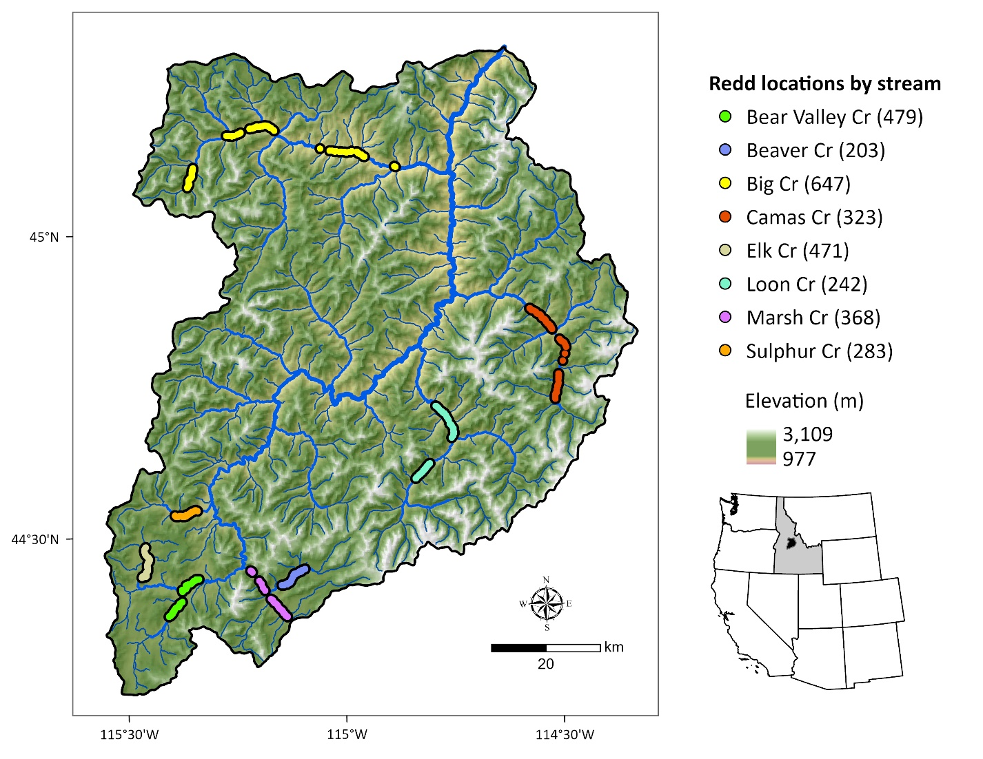Figure 1. Middle Fork Salmon River watershed illustrating major tributaries and locations of georeferenced Chinook salmon redds from 2002 to 2005 (count of redds per stream given in parentheses). Point locations were dissolved for visualization.

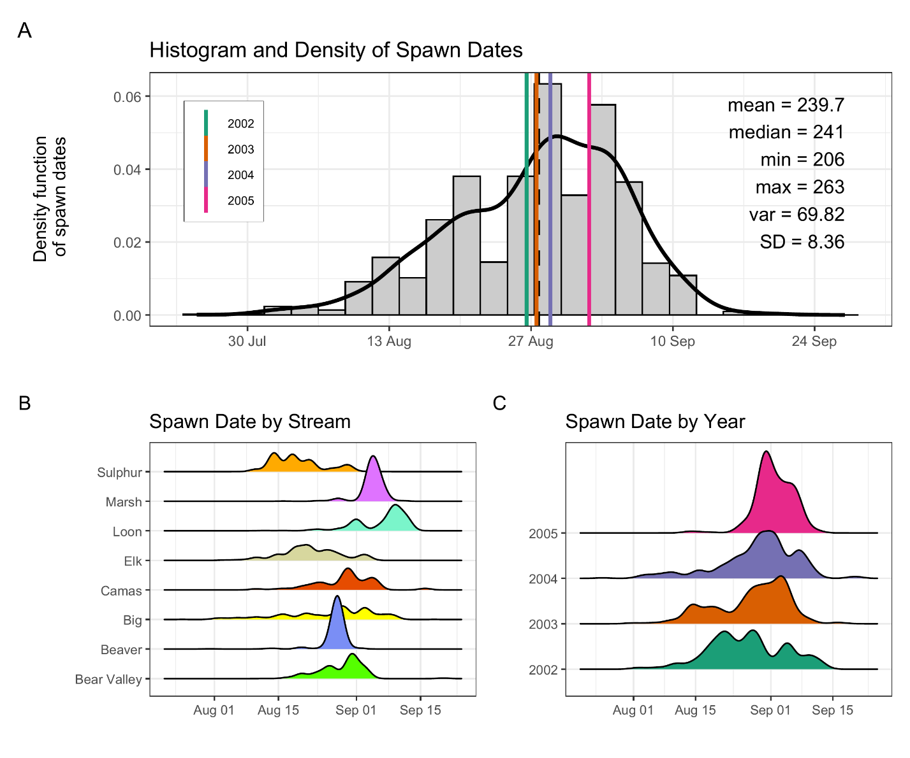
Figure 2: Histogram and density of Chinook salmon spawn timing across all streams and years (A), by stream (B), and by year (C). In panel (A), the histogram and kernel density illustrate the overall distribution of spawn dates; vertical-colored lines illustrate year-specific means, and the black dashed line depicts the global mean. Spawn timing was generally unimodal, peaking in late August to early September.

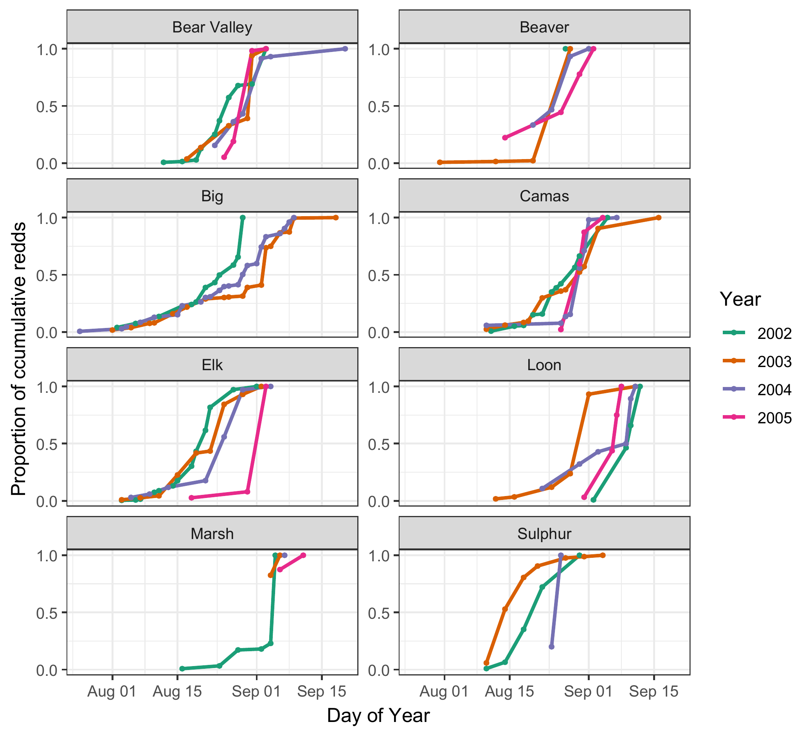
Figure 3. Proportion of cumulative Chinook salmon redds over time (day of year) across years (2002–2005) and streams. Each line represents a different year, denoted by color. Stream-specific panels illustrate temporal variation in the progression of spawning activity, as measured by cumulative redd counts normalized to the maximum value in each stream-year combination. From 2003-2005, only 2, 1, and 2 redd surveys, respectively, were completed in Marsh Creek.

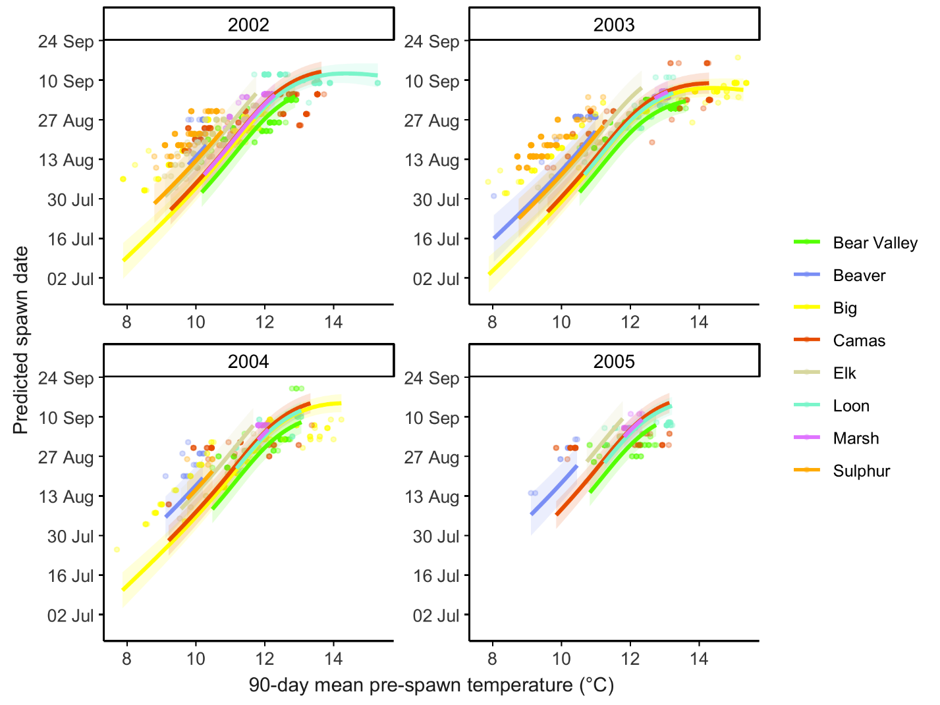
Figure 4. Predicted relationship between spawn timing and 90-day pre-spawn mean temperature by stream and year. Lines represent population-level model predictions from the final mixed-effects model. Colored points illustrate observed spawn timing; shaded ribbons represent 95% confidence intervals.

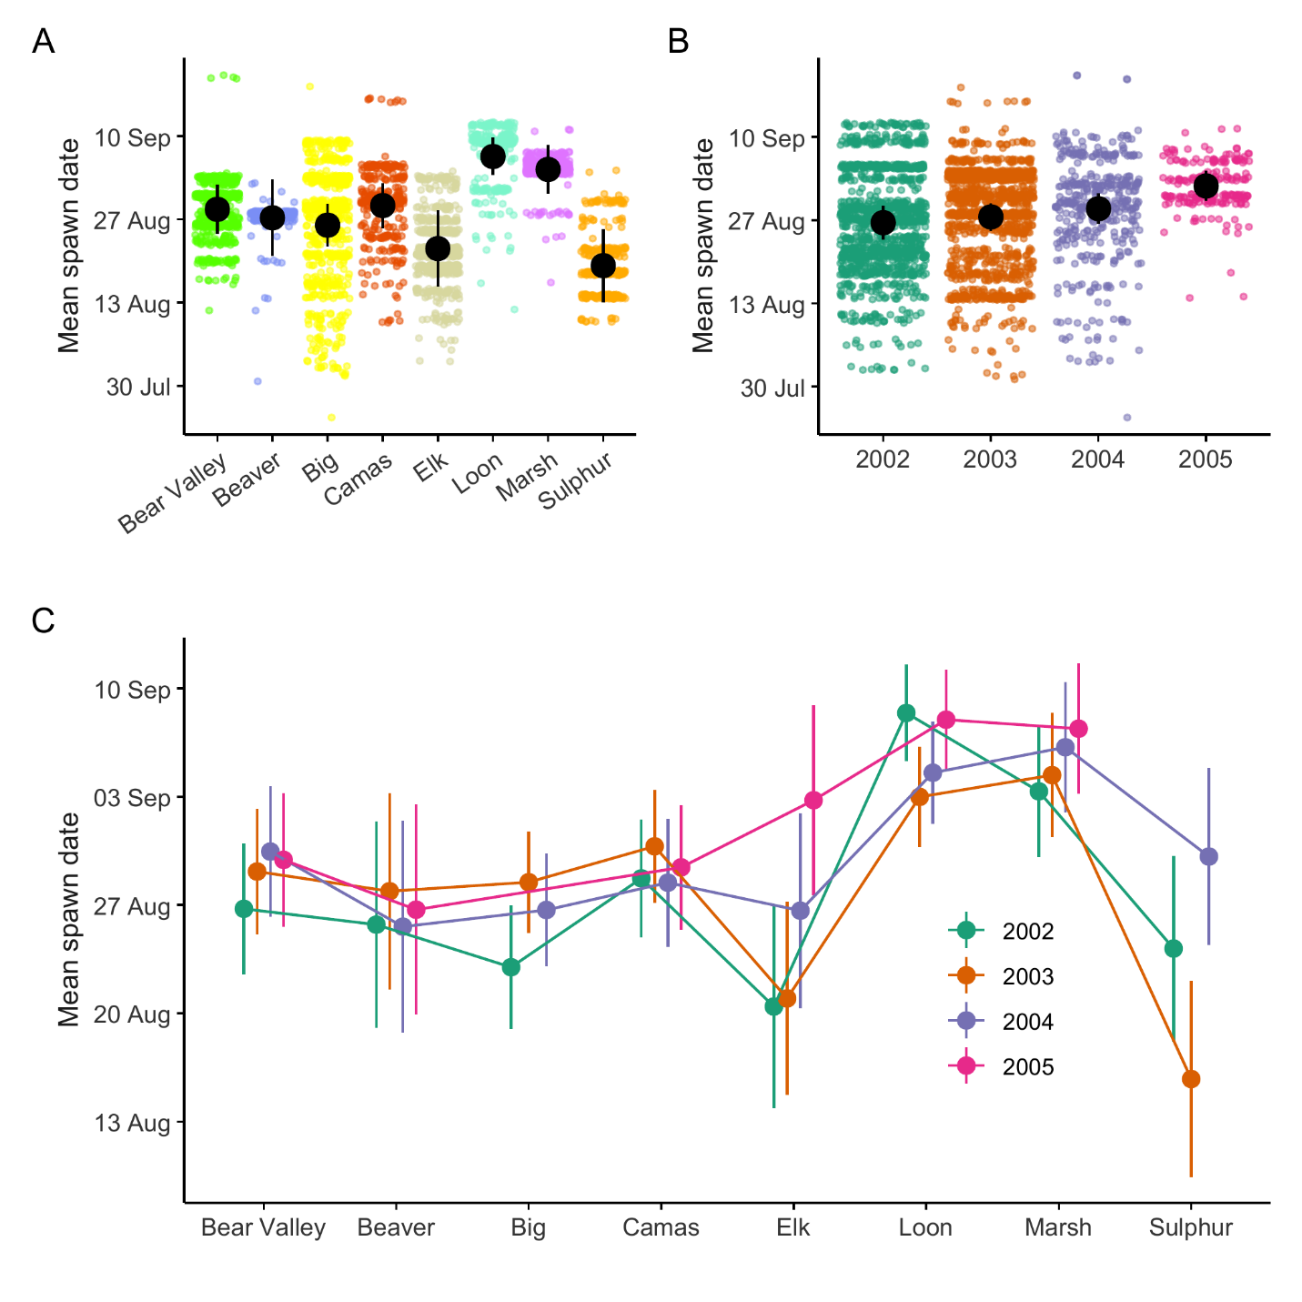
Figure 5. Predicted mean spawn dates by stream (A), year (B), and stream × year (C) from the final mixed-effects model. Black points and lines in panels A and B represent estimated marginal means and 95% confidence intervals averaged over random effects. Colored points illustrate individual redd observations. Colored points and lines in panel C represent stream-specific marginal means and 95% confidence intervals by year.

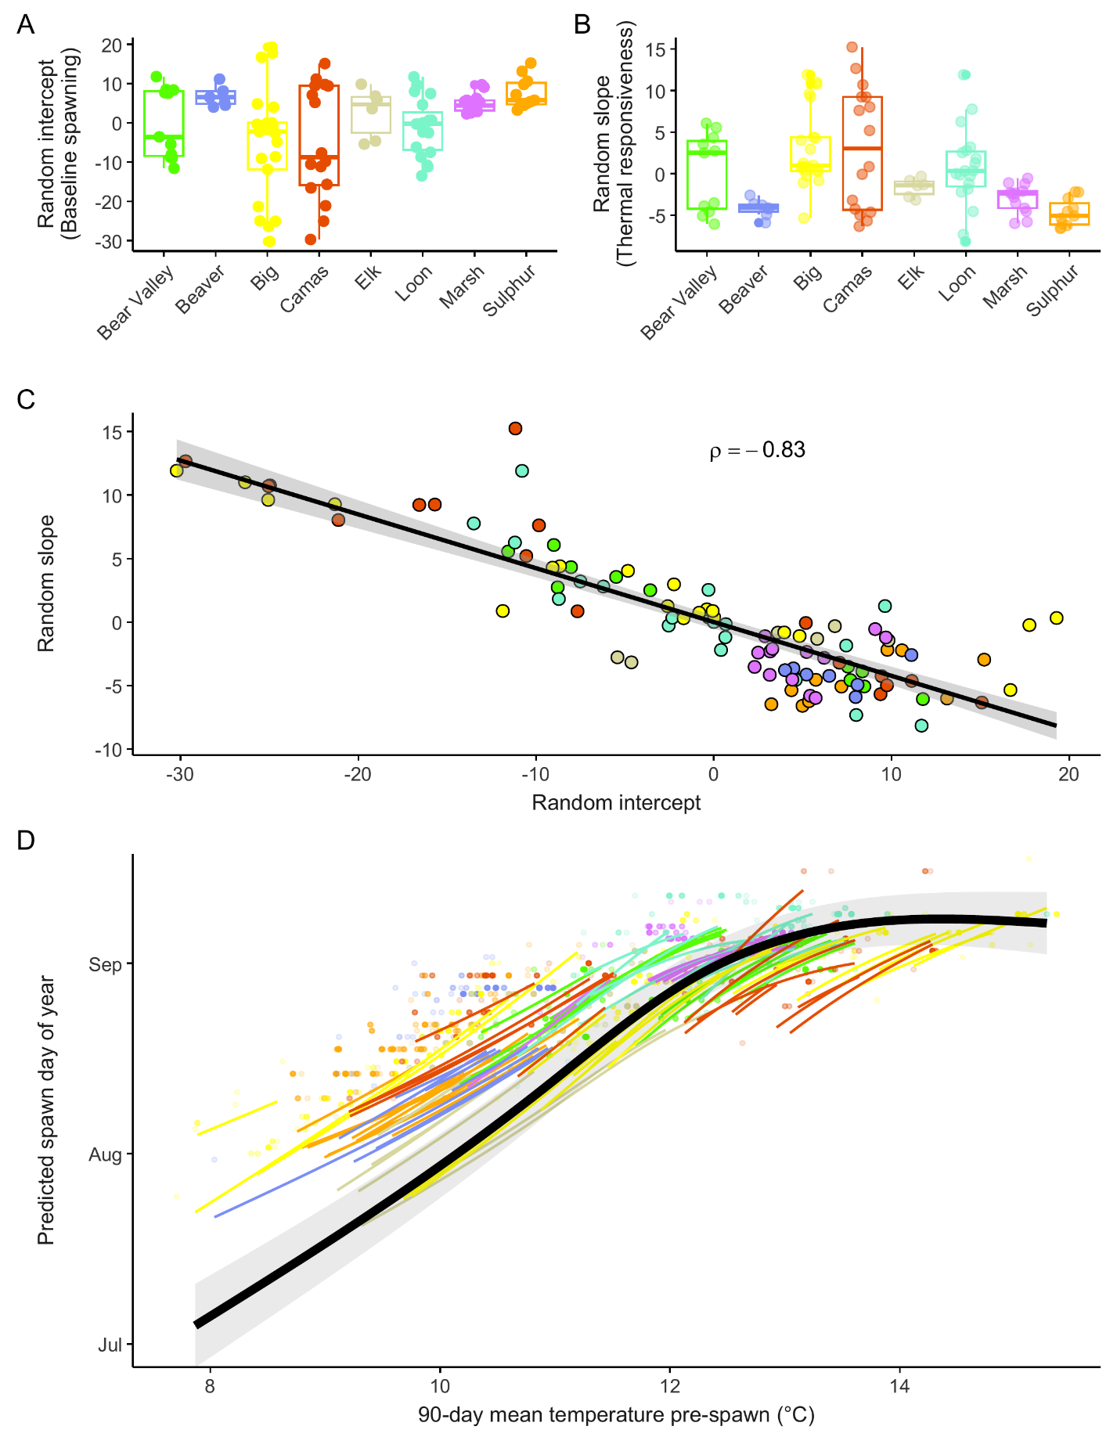
Figure 6: Reach-level (COMID) random effects and predicted spawn timing relationships from the final mixed-effects model. (A) Random intercepts by stream, representing reach-level deviations in baseline spawn timing after accounting for fixed effects; positive values indicate later-than-expected spawning. (B) Random slopes by stream, representing reach-level deviations in thermal sensitivity; larger positive values indicate stronger temperature dependence. Points in A and B represent individual COMIDs. (C) Correlation between random intercepts and slopes across all COMIDs, colored by stream; the strong negative relationship (ρ = −0.83) indicates that reaches with earlier baseline spawn timing exhibit greater thermal sensitivity. (D) Predicted temperature–spawn timing relationships for individual COMIDs (colored lines) and the population mean response (black line with 95% confidence interval).

